|  |
| --- |
| **D:\CE\WhatsApp Image 2021-05-08 at 4.35.03 PM.jpeg**  **“CULTIVATING EXCELLENCE IN EVERY STUDENT”**  **RAKESH KUMAR**  **M.Sc. (Chemistry) B.Ed.**  **CTET, PSTET, HPTET qualified**  **thakurkumar82@gmail.com** |
| **Class:-XII (Sci.) Name of Student……………………**  **Subject:- Chemistry**  **10 year QuStions**  **Chapter-8**  **d- & f- block elements** |

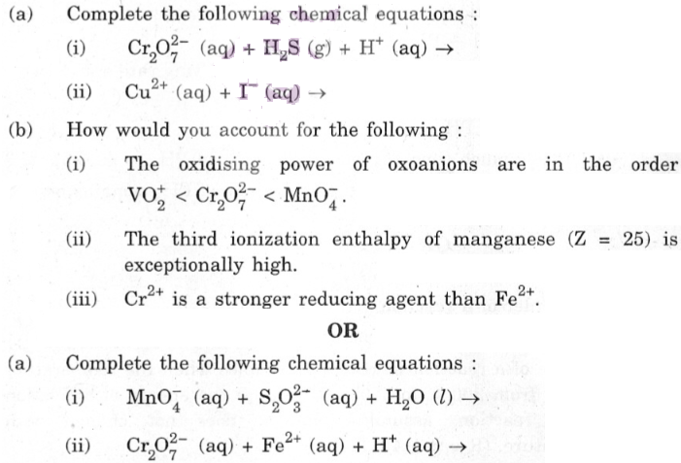

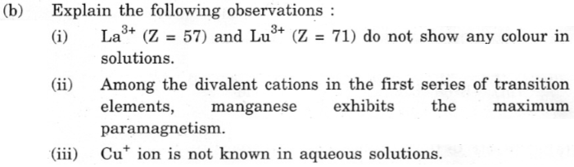

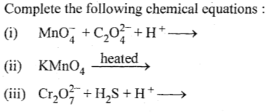

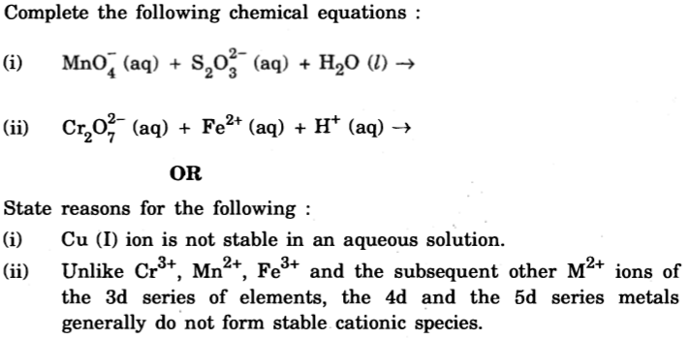

1. Explain (i) Transition metals show variable oxidation states. (ii) Zn, Cd and Hg are soft metals. (iii) EO value for the Mn3+/Mn2+ couple is highly positive (+ 1·57 V) as compared to Cr3+/Cr2+.
2. (a) Write one similarity and one difference between the chemistry of lanthanides and actinide elements.

(b) Following are the transition metal ions of 3d series: Ti4+, V2+, Mn3+, Cr3+ (Atomic numbers : Ti = 22, V = 23, Mn = 25, Cr = 24)

Answer the following:

(i) Which ion is most stable in an aqueous solution and why?

(ii) Which ion is a strong oxidizing agent and why?

(iii) Which ion is colorless and why?

1. 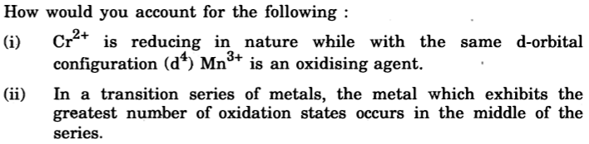

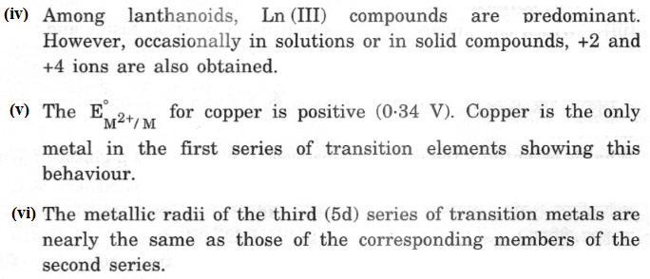

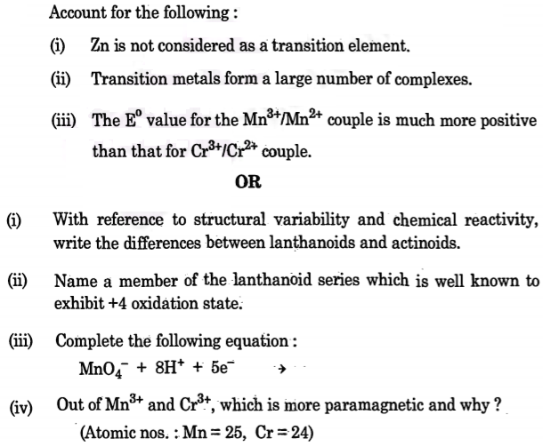

1. Complete the following equations :

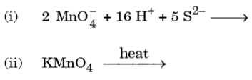

1. How would you account for the following: (i) Cr2+ is reducing in nature while with the same d-orbital configuration (d4) Mn3+ is an oxidizing agent.

(ii) In a transition series of metals, the metal which exhibits the greatest number of oxidation states occurs in the middle of the series.

(iii) State reasons for the following: (a) Cu (I) ion is not stable in an aqueous solution. (b) Unlike Cr3+, Mn2+, Fe3+ and the subsequent other M2+ ions of the 3d series of elements, the 4d and the 5d series metals generally do not form stable Cationic species.

1. 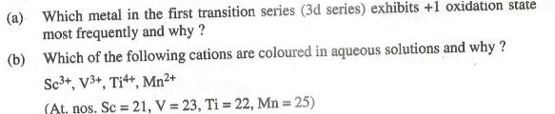

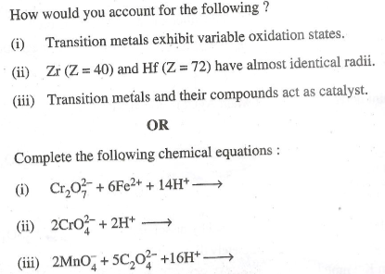

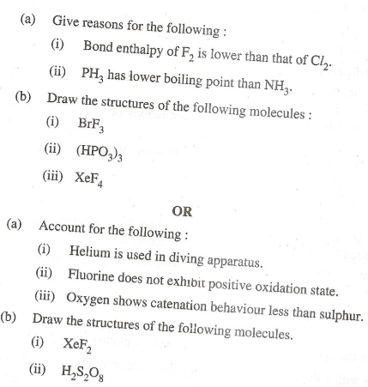

1. How would you account for the following:

(i) Actinide contraction is greater than lanthanides contraction. (ii) Transition metals form colored compounds. (iii) Why-do actinides show a Wide range of oxidation states·? Write one similarity between the chemistry of lanthanides and actinides.

1. Account for the following; (i) Zr and Hf have almost similar atomic radii. (ii) Transition metals show variable oxidation states. (iii) Cu+ ion is unstable in aqueous solution.
2. 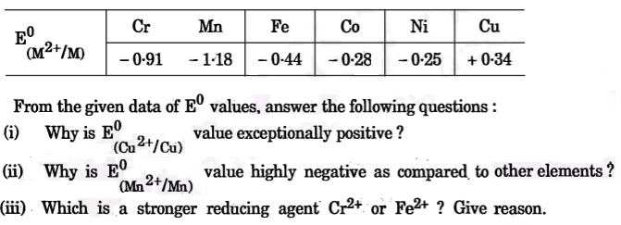
3. 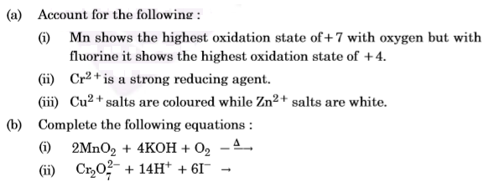Give reasons: (i) Mn show the highest oxidation state of +7 with oxygen but with fluorine it shows the highest oxidation state of +4. (ii) Transition metals show variable oxidation states. (iii) Actinides show irregularities in their electronic configurations.

**…………………………….**